Case Study for Selenium

**Application**: Flight Reservation System

**URL**: <http://newtours.demoaut.com/>

**Requirement**: To create an automation testing solution to test an end to end scenario.

**Tools and Technology**: Selenium Webdriver, Java, TestNG,

**Following test cases need to be automated:**

# Login Page

1. **On the login page, verify that current date is displayed on top section.**
2. **Verify that image of Aruba is displayed under featured destination**
3. **Verify that when user enters incorrect username and password then following section should be displayed. Also try for 10 invalid username and password (mercury1 – mercury10)**

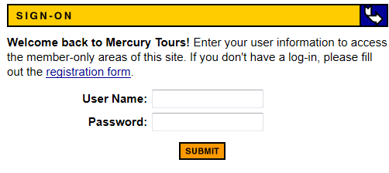

1. **Verify that when user enters valid username and password then search flight page should be displayed.**

## Search Flight Page

1. Under the field “Departing From” , the options New York and London should be available
2. User should be able to do valid search based on “from”, “to” and “Service Class”
3. After searching for the flights , “Select Flight” page should be displayed

## Select Flight Page

1. The order of the flights displayed should be sorted on its price
2. Verify that headers under following section are centrally aligned and its background color is blue

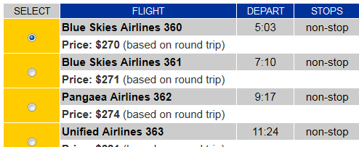

1. User should be able to select the flight having second highest price.

## Book a Flight page

1. Verify that details of the flight displayed is same as selected in “Select Flight Page”

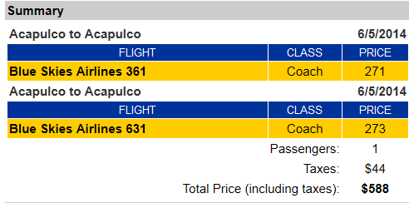

1. Verify that the total price shows the correct sum.
2. The mandatory fields on this form should be in red color.
3. Enter the required information in the fields and book the flight

## Confirmation Page

1. On confirmation page, validate booked flight is appearing and get flight confirmation number.
2. User should be able to sign off after the booking is done.

Notes:

1. Application url, username and password should be fetched from a configuration file.
2. For validations use TestNG default assertions
3. Use System.out.println where you have to print the details like booking number
4. For invalid login use TestNG parameterizations techniques